## TRACMAP SETUP

## On site setup before the operation

* Remind the helicopter coordinator of the tracmap settings as per screenshot below (take a printout of this along with you)
* Confirm helicopter IDs, pilots, buckets, swathes, etc. with helicopter coordinator and site supervisor (these can be different to what is in the SOW). Record on your summary sheet.
* Confirm with site supervisor which buffer to use for boundary runs (maximum or effective swath) and trickle
* Clarify any other issues you may have
* Run Tracmap Utilities tool to set parameters and enter metadata. This will create a geodatabase with the required feature classes which can be used in the operation or saved as a backup ready to be used in case of emergencies.

### Tracmap Setup

Ensure that Tracmap GPS headunits are set consistently as per screenshot. Found under ‘Unit setup’ and ‘Admin’

* Un-tick the option for Zip files.

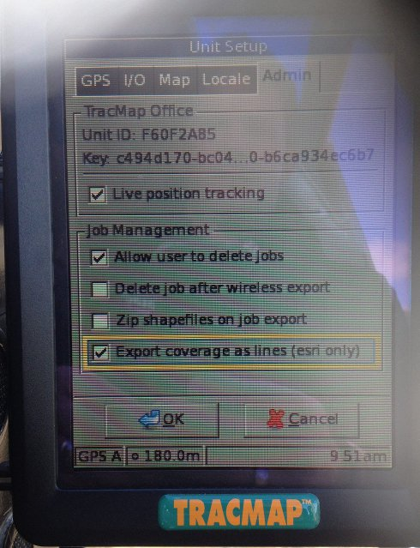

* Tick the option for EXPORT AS LINES.

* Ensure that files are exported in WGS84. The contractor should be able to choose the coordinate system upon export to USB.

* Ensure that the pilot is working to the same shapefile boundary that you have supplied, e.g. ‘*IBURN_TOX_YYMMDD*’.